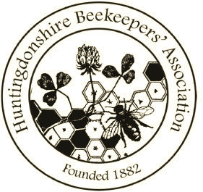
HBKA Open Honey Show 2021

ENTRY FORM

Entrants Name………………………………………………………………………….

Please send this form to the Show Secretary before the show or bring it, with your exhibits, from 10.00am and no later than 12.00pm on Monday 30th August. Judging is due to commence at 10.00am. Exhibits are not to be removed before 3.30pm on the day.

Please indicate clearly the classes for which you are entering. There is NO FEE.
Exhibitors may make more than one entry in any one class, in which case please indicate the number of entries.

Show Secretary-
Susanna Steiger, or email to: n.steiger@btinternet.com
7, Haycraft Close
Grafham
PE28 0GA

 | CLASS | No. of  ENTRIES
1 | Two 1 lb jars Light Run Honey
2 | Two 1 lb jars Medium or Dark Run Honey
3 | Two 1 lb jars Creamed Honey
4 | 1 lb jar Natural Set Honey and 1 lb jar Creamed Honey and 1 lb jar  Clear Honey
5 | Two 1 lb jars Granulated Honey
6 | Two 1 lb jars Chunk Honey
7 | Cut comb
8 | Section
9 | 1 lb Jar covered in foil to be judged on aroma and taste only
A | Novice 1 x 1 lb jar Run Honey
B | Novice 1 x 1 lb jar Set Honey
10 | One Shallow Comb suitable for extraction
11 | Three (3) x 1 oz Blocks of Natural Beeswax
12 | One Cake of Beeswax 8 oz (minimum weight)
13 | One Cake of Beeswax from a fancy mould
14 | Two Dipped Beeswax Candles
15 | Two Moulded Beeswax Candles
16 | Two Rolled Beeswax Candles
17 | One Honey Cake as per recipe
18 | Six Honey Biscuits - recipe to be submitted
19 | Six Small Honey Cakes – recipe to be submitted
20 | Honey Sweets up to a maximum of 12
21 | An Exhibit of Beekeeping Interest
22 | A Photograph of Beekeeping Interest
23 | One Bottle of Mead
24 | One Bottle of Melomel or Metheglin
25 | “Open’ Honey Cake. Recipe to be included with list of ingredients
Total number of exhibits:

Novice class is open to any HBKA members who have never won a 1st in any competition.

